**Name : omar magdy fathy saeed**

**B.N: 560**

**Date : 1/6/2020**

**Topic:** **Big Data**

**Github link :**

**Github page :**

**Application brief :**

**Big data is a new driver of the world economic and societal changes. The world’s data collection is reaching a tipping point for major technological changes that can bring new ways in decision making, managing our health, cities, finance and education. While the data complexities are increasing including data’s volume, variety, velocity and veracity, the real impact hinges on our ability to uncover the `value’ in the data through Big Data Analytics technologies. Big Data Analytics poses a grand challenge on the design of highly scalable algorithms and systems to integrate the data and uncover large hidden values from datasets that are diverse, complex, and of a massive scale. Potential breakthroughs include new algorithms, methodologies, systems and applications in Big Data Analytics that discover useful and hidden knowledge from the Big Data efficiently and effectively.**

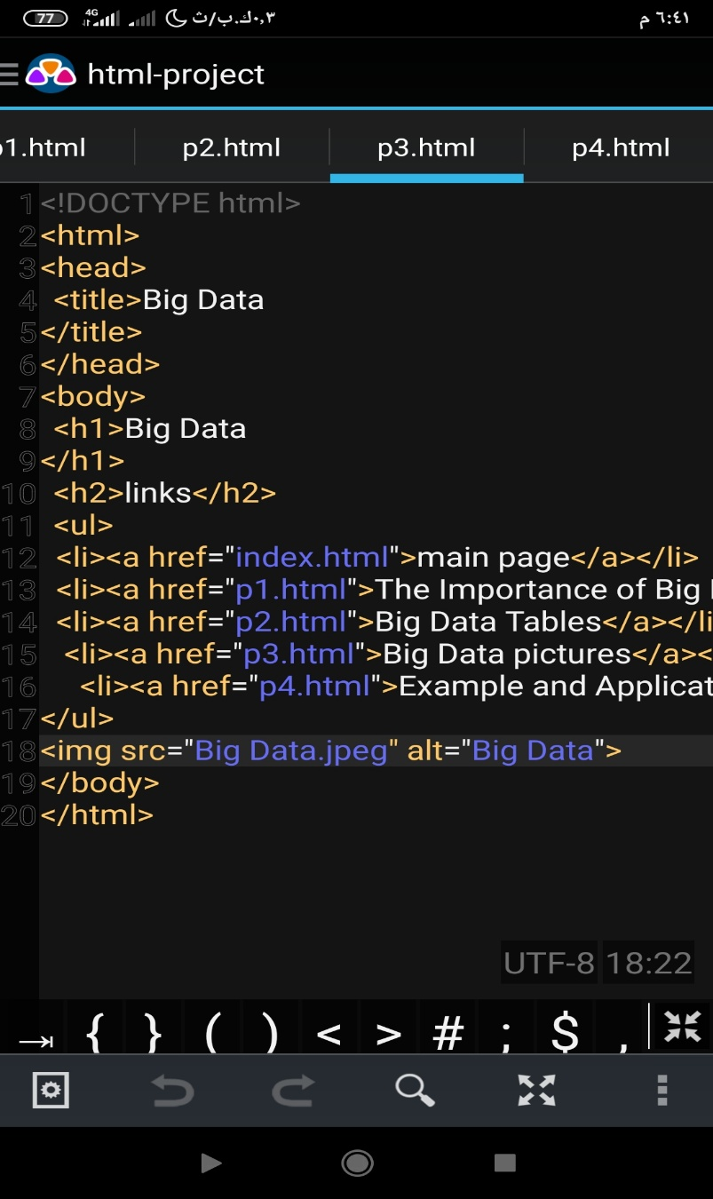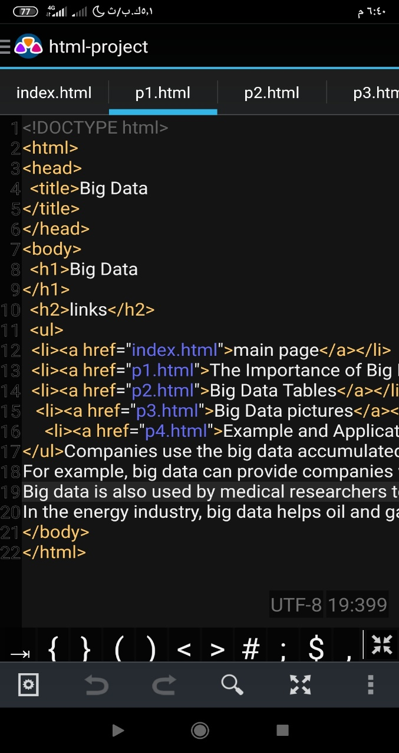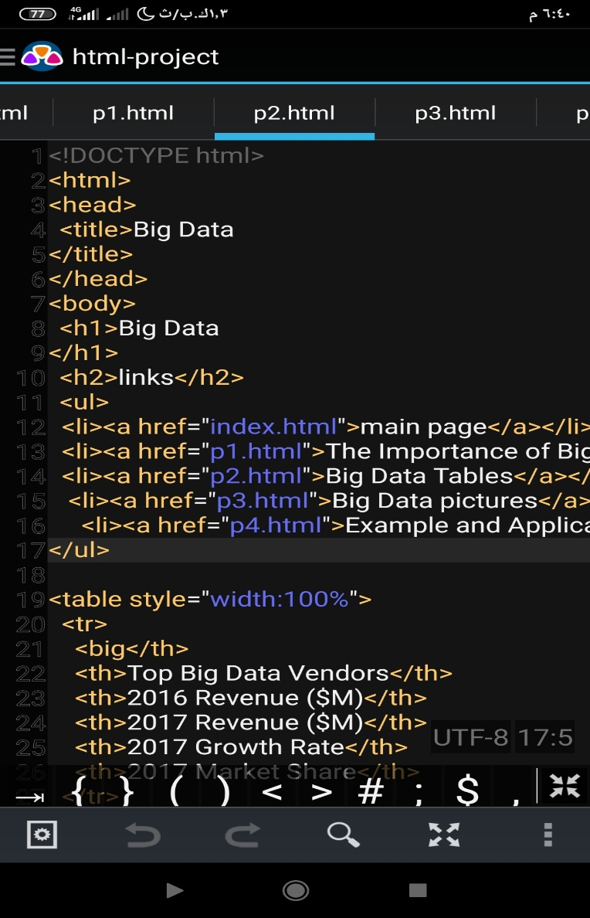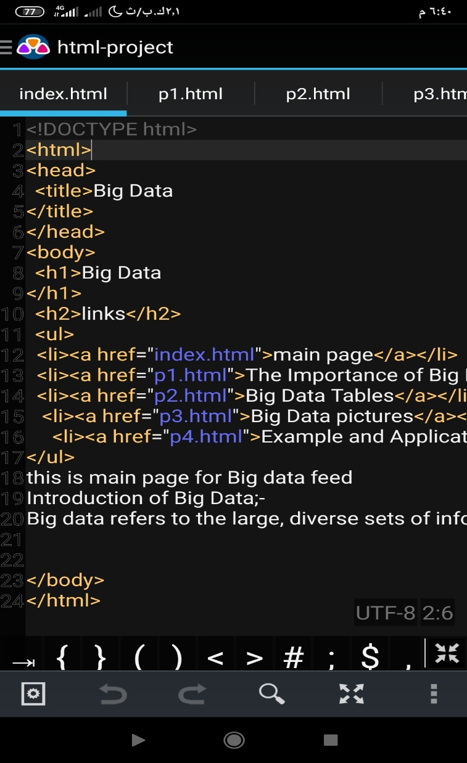**Screeshots code :**

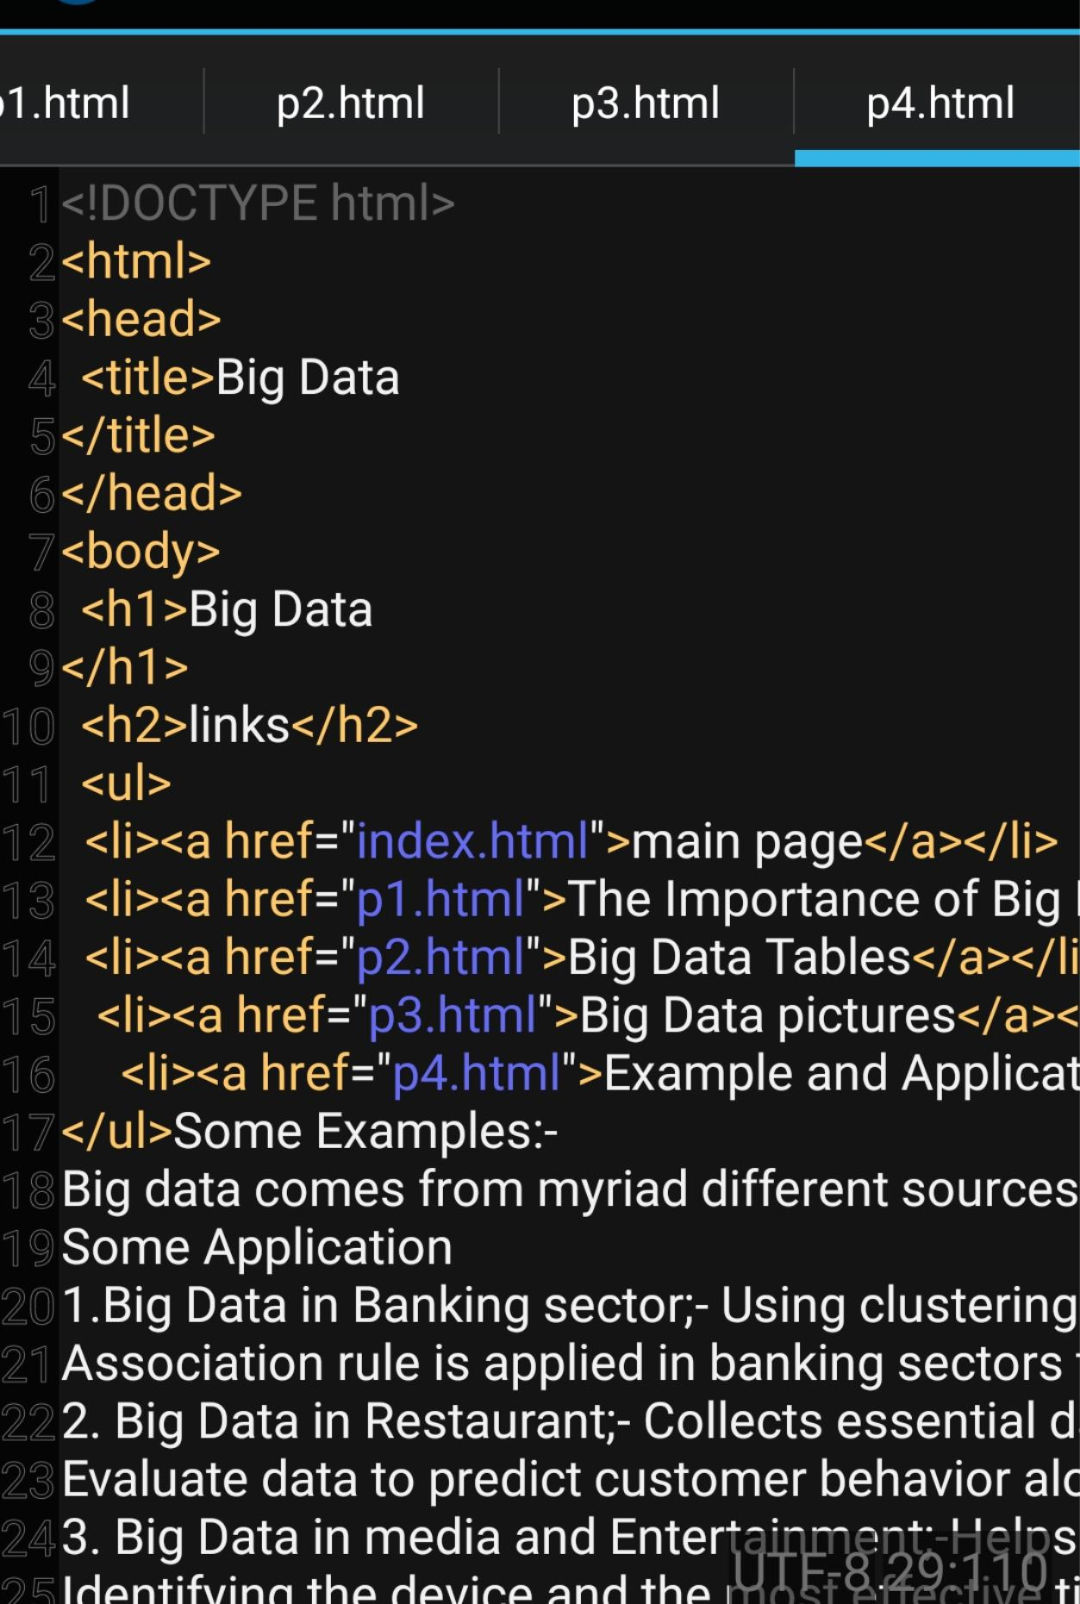

**Screenshot project:-**